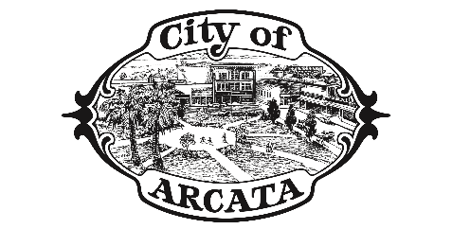

PRESS RELEASE
FOR IMMEDIATE RELEASE
Media Contact: Logan Rosselli
Communications Specialist, City of Arcata
lrosselli@cityofarcata.org
(707) 825-4872

ARCATA HOSTS SECOND PUBLIC WORKSHOP AND
POP-UP EVENT ON SAMSIP

Arcata, CA, April 11, 2025 – The City of Arcata is hosting a second public workshop on the South Arcata Multimodal Safety Improvement Plan (SAMSIP), on Tuesday, April 29 for community members to provide feedback.

SAMSIP is focused on enhancing multimodal safety on the U.S. Highway 101 and State-Route 255 interchange, as well as safety and beautification enhancements along Samoa Blvd and G street, South of Samoa Boulevard. The goal of the project is to improve and bridge gaps in multimodal access, making it desirable for all ages and abilities to use active modes of travel in south Arcata. This project aims to address the inequitable conditions created by U.S. Highway 101 and State Route 255 which disincentivizes bicycle and pedestrian travel in favor of vehicular transportation. In addition, the project will explore options for beautifying and improving safety along Samoa Boulevard and South G Street.

The City of Arcata will be hosting its second public workshop event for the South Arcata Multimodal Safety Improvement Plan (SAMSIP) on Tuesday, April 29. The workshop will take place in the Marsh Commons Meeting Room at 101 H St, Suite A from 5:30 to 7:00 p.m. The purpose of this second interactive workshop is to share initial improvement concepts, based on needs identified by the community, and receive additional feedback about potential improvements that should be included in the plan.

In addition to the workshop, there will be a pop-up demonstration of potential improvements on Saturday, April 26 from noon to 4 p.m. near 145 G St. This will be an opportunity to get a feel for what future safety improvements might look like on the ground and provide input. This temporary installation of traffic calming features includes buffered bike lanes, landscaped bulb-outs and enhanced visibility at crosswalks.

The end goal of this planning process is to produce concept designs that reflect the community’s input and needs to prepare for future phases. On the City’s SAMSIP webpage, community members will find both an online survey and a Social Pinpoint interactive map to help contextualize the project and provide the City with feedback. The City of Arcata encourages the community to utilize both the survey and the interactive map to provide input as the project progresses.

For details on SAMSIP and to provide feedback, please visit the webpage at cityofarcata.org/samsip or contact the City of Arcata Building and Engineering Department at (707) 825-2128 or engineering@cityofarcata.org.

###
Corresponding Image: SAMSIP Events Flyer courtesy of Redwood Community Action Agency (RCAA)

For additional information, the media may contact:
Jak Kirchubel, Engineering Technician II
Engineering Department, City of Arcata
jkirchubel@cityofarcata.org
(707) 825-2174

